Castle Incoming Lead Screening Process
#1) Is the project a fit with what Castle is best at? Kitchens, Baths, basements, attics, additions, and generally projects that focus mostly on the interior of homes. Here is what we don’t do, and who we recommend:
- Detached Garages (Minneapolis Garage - Joe Slavec - mplsgarage@gmail.com; 612-940-7849)
- Roofing, Siding, Soffits, Fascia, Gutters (Stinson Services – Heidi Stinson p: (952) 300-6190 | o: (952) 933-4510 e: heidi@stinsonservices.com | w: www.stinsonservices.com a: 7391 Bush Lake Rd, Edina MN 55439)
- Landscaping (Field Outdoor Spaces - Jason Rathe –e: fieldoutdoor@gmail.com w: http://fieldoutdoorspaces.com/ p:612-209-5223)
- Plumbing (Johnson Plumbing - Aaron Johnson – p: 612-221-8430 e: johnsonplumbinginc@gmail.com )
- Electrical (Sierra Electric – Mitch Eggen p: 612-532-3727 e: sierraelectricinc@gmail.com)
- Flooring: Marmoleum, Cork, Wool Carpet, Bamboo: Floors of Distinction a:12642 Bass Lake Rd, Maple Grove, MN 55369 p:(763) 553-1800 w:http://floorsofdistinction.com/
Cambria Countertops: Select Surfaces a:2800 Fairview Ave N, Roseville, MN 55113 p:(651) 483-1576 w:http://selectsurfaces.com/
Recycled Glass Countertops: Dakota Surfaces p: (612) 968-1412 w:http://dakotasurfaces.com/ or
Element Surface (Rust Brothers)a: 2303 NE Kennedy Street, Suite 7 Minneapolis, MN 55413 P:866.503.3341, W: http://rustbrothers.com/sustainable-surfaces/element-surfaces/
Chemical sensitivity type projects/remodeling: Healthy Exposure Construction, Inc. - Darren J. Vigil
E: healthyexposure1@gmail.com, w: www.HealthyExposure.com, p: 612-216-2453, c: 612-237-4819

2) Area Served: 21 Miles from ProHQ in radius = 25 miles of driving. Also please let people know that we do charge for drive time and projects that are near the edge of our service area typically cost 2-3% more than projects very close to our HQ. Also depending on our work load we may arbitrarily tighten or loosen this circle.
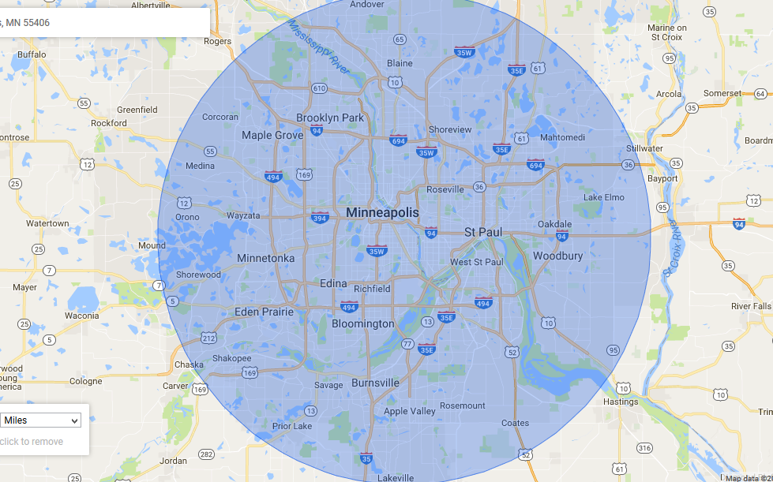
Our Target area especially for small projects is even closer to our HQ. Here is a 7 mile radius.
3) Timelines: 1st Visit 1-2 Weeks, Budget Analysis 1-2 Weeks, Design & Planning 6+ weeks (average is 8 weeks and larger projects take longer), Start date 4+ weeks. Overall it is2-3 months before we can start. Does that work for your timeline?
5) What is your budget for your Project?
Bathroom Remodel - Moderate (gut to studs) $18,297.17 $23,056.69
Bathroom Remodel - Classic (gut to studs) $29,695.33 $32,562.06
Bathroom Makeover $15,758.73 $17,274.17
Bathroom Add-on Main or 2nd flr $35,125.66 $38,518.84
Bathroom Add to Basement $28,886.12 $35,674.85
Bathroon Addition Example $59,257.60 $64,946.95
Basement Family Room $37,021.15 $40,606.26
Basement Remodel 500 SF $71,904.22 $78,877.98
Full Basement, Bath & Laundry Remodel $97,977.69 $107,451.69
Kitchen Addition $113,442.07 $124,464.53
Kitchen Remodel Moderate $42,723.54 $46,859.40
Kitchen Makeover $23,416.35 $25,689.73
Kitchen Remodel Classic $65,867.80 $72,259.58
Attic Finish w/ Shed Dormer $107,127.24 $117,506.46
Attic Finish $45,340.38 $49,737.92
Attic Master Suite $73,054.98 $80,124.30
Attic Master Suite v2 (Based on Real Project) $97,144.70 $106,571.54
3rd Floor Master Suite Finish with Dormer $219,929.21 $241,254.26
Shed Dormer and Attic Finish $136,866.90 $150,148.47
House Addition - Two Stories $186,898.23 $205,072.39
Sunroom Addition/3-Season $71,346.30 $78,271.31
Screen Porch $39,912.56 $43,781.94
Lower Level Finish – New Home $100,962.52 $110,746.77
Home Office Remodel $20,312.56 $22,282.88
Family Room Addition $85,732.70 $94,037.85
Master Suite Addition $102,044.22 $111,956.14
Second Story Addition 500SF $132,496.32 $145,326.70
Second Story Addition 1000 SF $200,625.42 $220,091.41
Second Story Addition Shell Only 1000 SF $137,183.62 $150,463.23
Deck - Treated Lumber 192 SF $12,205.05 $13,386.55
Deck - Cedar 192 SF $13,289.57 $14,579.52
Deck - Composite 192 SF $15,865.48 $17,413.03
Window Replacement Clad/Wood ea opening $1,100 +$300 for finishing
Window Replacement Vinyl Pocket ea opening $900
Window Sash Replacement (wood interior) ea opening $750 +300 for finishing

