How to Roll over your Vanguard IRA to Transamerica 401k
- Set up your Transamerica account.
  - 401K Enrollment Form
  - 401K Information Kit
  - 401K Webinar
- Information on rolling over your Vanguard IRA into the new Transamerica 401k plan.
Advantages
- Investment gains in your account remain tax-deferred
- Avoid early withdrawal penalties and taxes associated with cashing out your account
- Fiduciary oversight is managed by the plan trustee
- Assets are protected from the claims of creditors
Disadvantages
- The new employer's plan may not allow rollovers from previous employer-sponsored plans
- The new employer's plan may have less flexibility than an IRA and may have fewer investment options
Review the fees and expenses you pay, including any charges associated with transferring your account, to see if consolidating accounts could help reduce your costs. Be sure to consider whether such a transfer changes any features or benefits that may be important to you.
- How to roll over your Vanguard IRA into the new Transamerica 401k plan
  - The process to roll over your account begins by logging into your Vanguard retirement account. Note you can also call Vanguard at 847-662-7447.
  - The first step once in your account is to go to your Simple IRA and click on your Simple IRA account.
- Transfer Funds from Investments to Settlement Account
  - Once in the Simple IRA account the investments you have made, such as the “Vanguard Target Retirement 2040 Fund” will show up. Choose “transact” and then “Exchange” next to accounts with investments you wise to rollover.
  - Under the where’s the money coming from on the left choose your Simple IRA. Enter the amount you wish to transfer.
  - On the right choose “Federal Money Market”, choose continue, accept the prospectus.
  - Click Submit. This will transfer your funds to a settlement account so you can withdraw them.
  - Note: This may take several days to complete the transaction. After complete you will be able to move to the next step.
- Distribute Funds for Rollover
  - Return to your account home page and choose the “Forms” tab at the top and then choose the “Add or Remove money, trade within your account”.
  - Under that drop down choose “Sell shares of an existing account (includes retirement distributions and nonretirement accounts).
  - Then choose (VBA) Vanguard Brokerage Account IRA Distribution option.
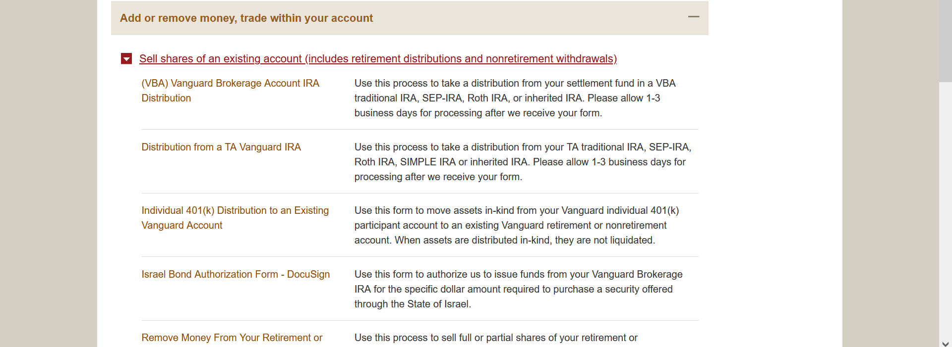
  - The process is an online form can be saved and you can come back later.
  - Verify your information
  - Reason for Distribution: Choose Traditional rollover with an employer plan (a 401k, for example).
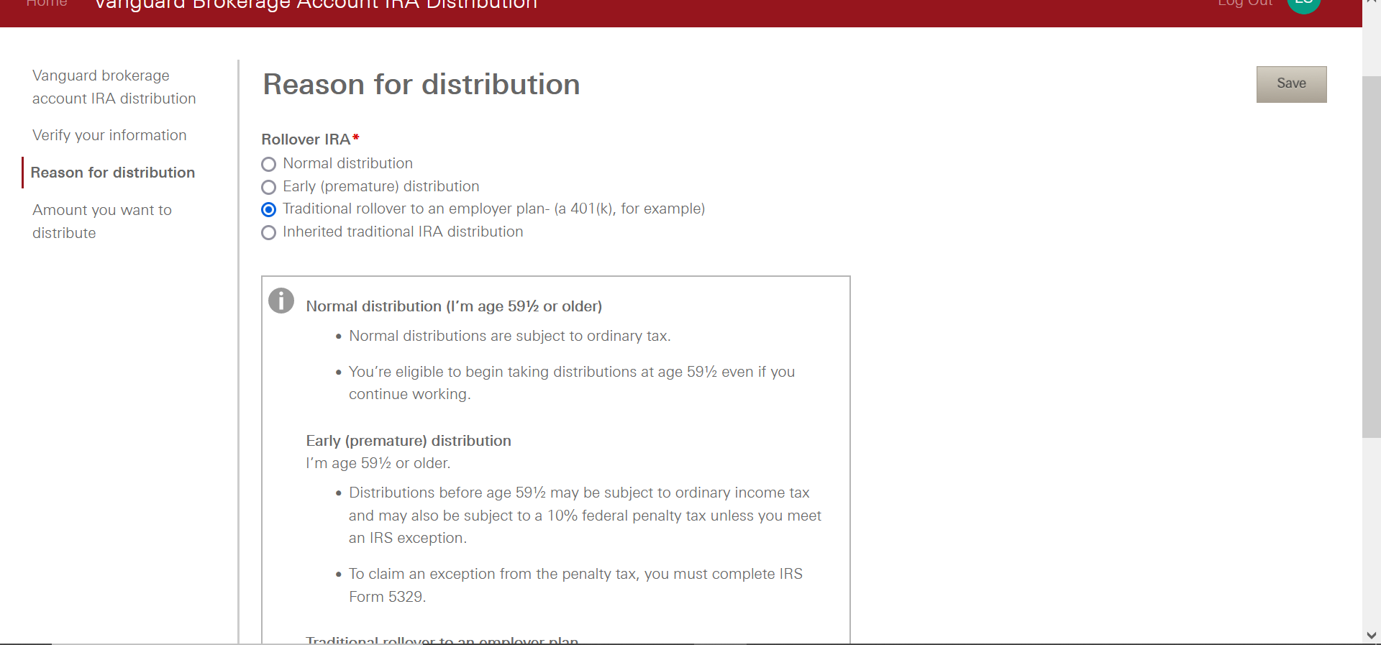
  - Choose the amount to transfer from your settlement account.
  - Choose check to be mailed. It is the easiest.
    - Check will be made out to Transamerica FBO Your Name
    - You do not need to endorse the check when you receive it.
    - Note: It is very important you mail in the check for deposit in a timely manner. You have 60 days to complete the deposit before it is considered a withdrawal which has serious penalties and tax consequences.
- Depositing the check in your Transamerica account
  - Call Transamerica at 800-755-5801.
  - Choose “Retirement” phone tree option.
  - Verify your account information. See step 1 above.
  - Let them know you would like to roll over your previous Simple IRA account into your new 401k.
  - They will email you a form with further instructions
Form Instructions
Four Simple Steps:
1. Contact your Plan Administrator or refer to your Summary Plan Description to make sure you’re eligible to roll over your Plan account balance from a prior qualified retirement plan.
2. Contact your prior Company and request a rollover distribution. If you have an IRA, contact your IRA investment manager and request a withdrawal. Be sure to have the distribution check made payable to Transamerica, FBO "Reference Your Name" (e.g., Transamerica, FBO Jane Doe) and have it sent directly to you.
3. Complete the Rollover Form below.
4. Return this form along with your distribution check to: Transamerica P.O. Box 28566, New York, NY 10087-8566. For overnight mailing: JPMorgan Chase TFLIC-Lockbox 28566, 7th Floor East Side 4 Metrotech Center Brooklyn, NY 11245.

Notes on Filling out the Form:
Previous Plan Information: Castle Building & Remodeling / Simple IRA
Skip Roth 401k section
Choose – All of this distribution amount would be taxable to me if I did not roll it over.
Fill in SS#
Sign
Keep a Copy of the Form and Check for your records.
Mail in form and check to address in red on form.

