Hey everyone!
I want to check in with everyone regarding receipts. We have some changes in the future that will impact how we are tracking things. Our customers will now be able to request receipts, this means we will need to be extremely diligent. We need all receipts turned in with the Category and Client. The email subject line should state the client’s name and category when turning them in to ensure they are being entered correctly. Please send within 5 business days to make sure we are as timely as possible and have the most correct financial information per job.
Example:
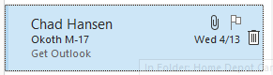
I thought I would share what things look like on my end and why properly coding makes a significant difference.
This is how Home Depot appears to me. It only lists a transaction date, PO, and amounts. This means It is super hard for me to track when something is missing. We need to make sure we are diligently coding every receipt that comes in. The lack of information on the statement makes it very difficult to figure out where it came from. This also includes all online purchases.
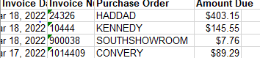
When you’re purchasing, make sure you are not only putting the client’s name, but your Initials and the category.
When you send a receipt directly to me, from the store, this is how it looks on my end. I rely on the PO to be listed with a Category, Client name, and your initials for tracking purposes.
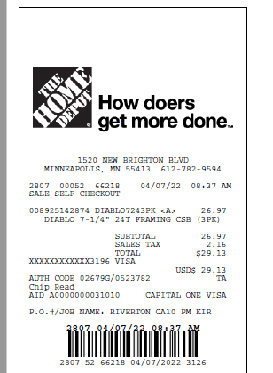
We need to all make sure every receipt is turned in. In the past, I have taken the date to look at where you clocked into and under what labor to enter the receipt. Often, there are multiple jobs under one day making it impossible for me to determine who it was purchased for.
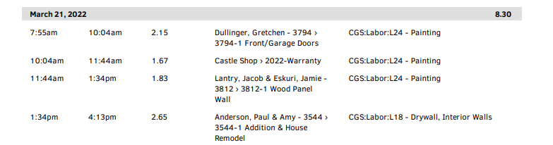

The changes coming, we cannot do this anymore as customers now have the right to every receipt to see where their money is going to.

